**Education**

**Science, Technology and Innovation**

**Technical and Vocational Education and Training**

**for the Youth**

**2016 in Africa**

**Department of Human Resources, Science and Technology**

**Report of activities**

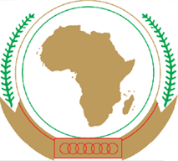

**African Union Commission**

**GUIDANCE NOTE**

**Continental Annual Report of activities (CARA)**

On the occasion of the first meeting of the Specialized Technical Committee Education-Science, Technology and Innovation and in the framework of monitoring and evaluating SCE 16-25, it is hereby recognized that the Continental Annual Report of activities (CARA) serves the purpose of reporting on consolidated basis at the continental level in the evolution of education in relation to the continental strategies of education, STISA-2024 and TVET strategy.

Each country will be responsible of consolidating information related to the school population and the budgetary effort in favor of the ESTI and Youth.

The CARA features five chapters

- HRST Report (AUC)

- Reports of member countries

- Reports of RECs

- Reports of partners and other stakeholders

- Continental Synthesis and Orientations

Elements from all member countries of the AU and stakeholders must reach the AUC (HRST) by 20 October of each year to allow the HRST Department of the AUC to submit the report to the team of ten (10) Heads of State and Government of the ESTI defenders in Africa at the AU summit in January.

At the Assembly meeting, a team of 10 Heads of State and Government will then disclose to their peers, the state of the ESTI and the progress of the implementation of continental strategies STISA -2024, SC-TVET and SCE: 16-25.

Therefore, all member states and all stakeholders are requested to prepare for the 2016 edition of this report. The information will be collected during the session of the CTS-I / ST.

**Annual Activity Report of the Department**

**HRST**

**2016**

**Summary of Country Activities**

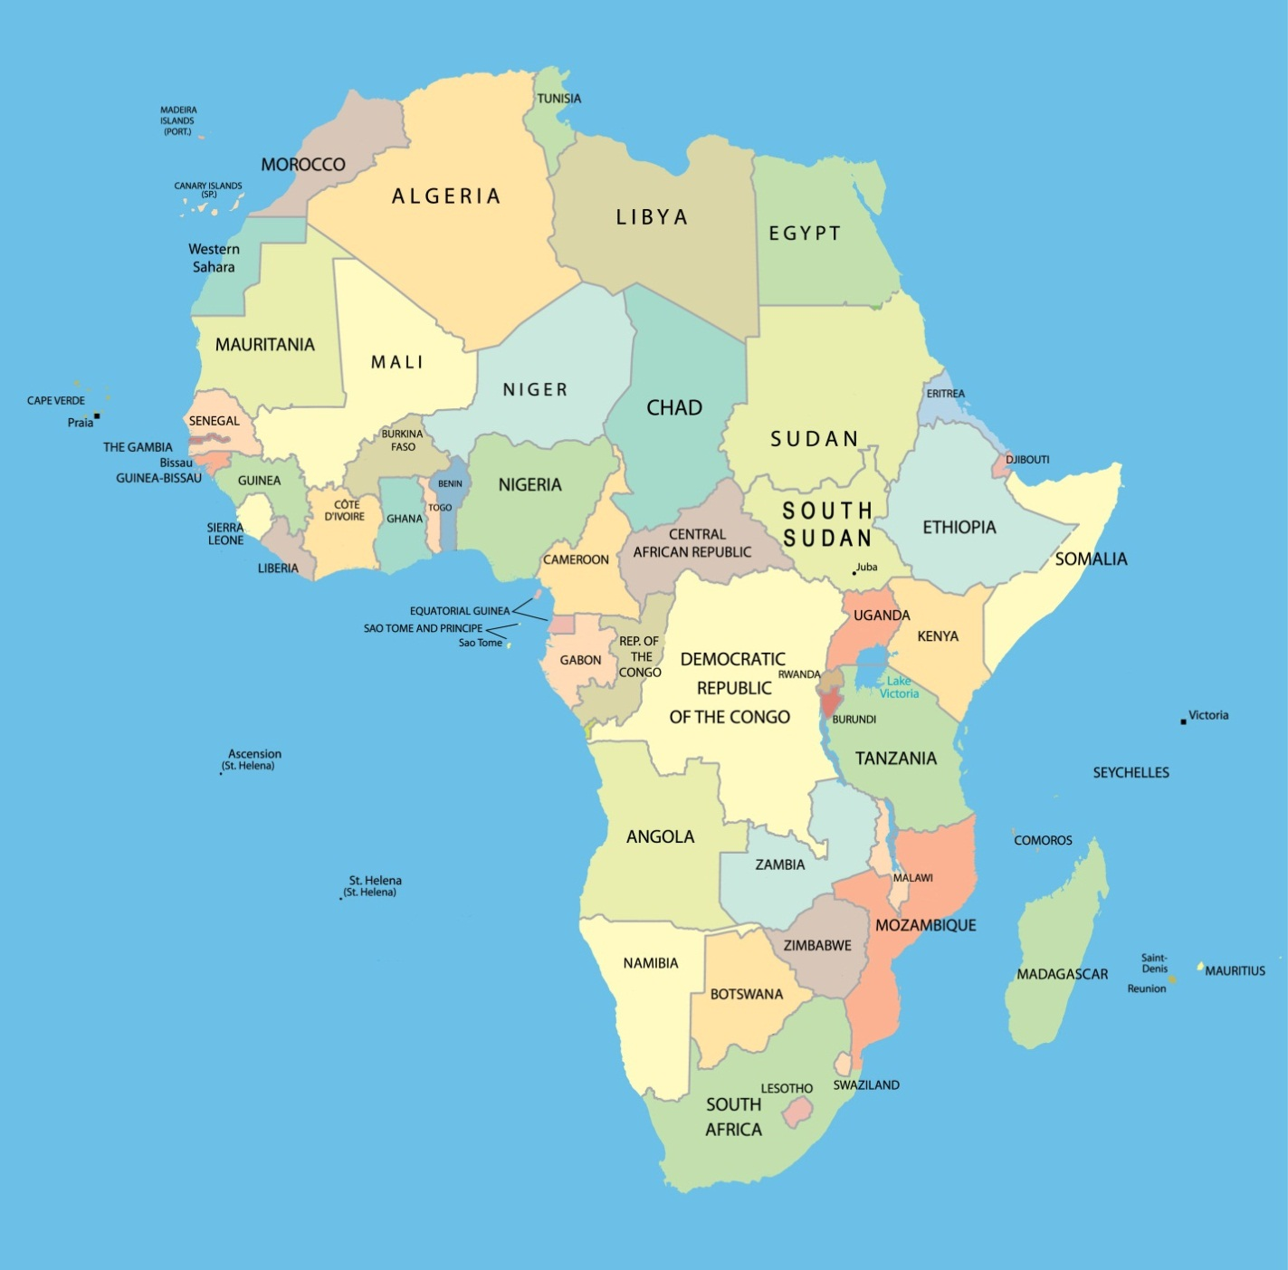

Each Member State of the African Union has been asked to present on an A4 size page, its main activities *in the sectors of Education (primary, secondary and higher). TVET(Technical and Vocational Education and Training), Science, Technology and Innovation, and Youth in relation to African Union Continental Strategies and Programs.*

*The information published here remains the responsibility of the respective governments.*

*Countries marked have answered our call.*

**Summary of Regional Economic Communities’ activities**

Each Regional Economic Community (REC) was asked to present on an A4 size page, its main activities in the sectors of Education (primary, secondary and higher), TVET (Technical and Vocational Education and Training), Science, Technology and Innovation, and Youth in relation to the continental strategies and the programs of the African Union.

The information published here remains the responsibility of the Regional Economic Communities.

The RECs not represented did not respond to our appeal.

|  |  |  |  |
| --- | --- | --- | --- |
| http://upload.wikimedia.org/wikipedia/en/9/98/Sadc_logo.png | **SADC** | **Member Countries (15) :** * South Africa *Angola *Botswana *Lesotho *Madagascar *Malawi *Maurice *Mozambique *Namibia *D. R. Congo *Seychelles *Swaziland *Tanzania *Zambia *Zimbabwe | |
| **Gaborone** | Population of SADC  **304 485 000 inhab.** | Global budget of SADC Members States: |
| Budget of SADC: |

|  |  |  |  |  |  |  |  |  |
| --- | --- | --- | --- | --- | --- | --- | --- | --- |
| General Information | | | | | | | | |
| Population % | | | | |  | Budget | | |
| Age | General Distribution | | Enrolled by cycle | | School Cycle | % | |
| **M** | **F** | **M** | **F** | REC MS overview | REC |
| 0 – 4 | 15 | 13.8 |  |  | Pre-primairy |  |  |
| 3 - 9 | 12.8 | 12 |  |  | Primary |  |  |
| 10-14 | 10.8 | 11.6 |  |  | Secondary |  |  |
| 15-19 | 10.4 | 9.8 |  |  | Higher |  |  |
| 20-24 | 9.1 | 9.3 |  |  | TVET |  |  |
| 25 - 35 |  |  |  |  | STI |  |  |

Introduction

SADC during the period October 2015-September 2016 implemented or implementing activities in accordance to the outputs of Revised Regional Indicative Strategic Plan (RISDP) in Education, Science, Technology and Innovation and Youth in relation to the Continental Education Strategy for Africa (CESA) and STISA Ministers Meeting responsible for these sectors were held in June 2016 and they approved policy /strategic frameworks/guidelines and recommendations. These are articulated below.

1. Education

**Primary and Secondary**: A Regional programme called Care and Support for Teaching and Learning (CSTL) aimed at ensuring that children and youth especially those that are orphans and vulnerable in SADC to realize their right to education, and achieve optimal education outcomes is being implemented. A CSTL Policy Framework was approved by Ministers In addition, Ministers approved a regional inclusive education strategy for learners with disabilities .

**Technical and Vocationnel Education and Training (TVET) : A** Regional Guideline on Recognition of Prior Learning (RPL) aimed at providing a common guidance and approach to be used by Member States in the recognition of prior learning of individuals acquired thorough different learning processes as part of their skills development plans and programmes and implementation of their national qualifications frameworks was approved by Ministers. In addition, the SADC TVET Strategic Framework is being revised to incorprate recently approved regional, continental and international framework. Furthermore, 15th July of each year was approved by SADC organs to recognised as Youth Skills Day by every SADC Member State to generate greater awareness of and discussion on the importance of technical, vocational education and training .

**Higher Education and Training. An** introduction of a regional VISA for students, academics,researchers and scientists to improve mobility within the region for the purposes of learning, teaching, and research was approved by MInisters. Universities in the region have been urged by Minsters to fast track the development and implementation of Credit Accumulation and Transfer as provided for in Article 7 of the SADC Protocol on Education and Training. On the Pan African University on Space Science, the host South Africa undertook a national audit on existing competencies in the area of space sciences and partner universities and identified. It is envisaged that the first intake of students will be in January 2017.

1. **Youth**

A SADC Youth Employment Promotion Policy was developed and approved by Ministers responsible for Employment and Labour and Social Partners in 2016.

SADC has developed a Strategy and Business Plan 2015-2020: Youth Empowerment and Participation for Sustainable Developed and implementation is underway. In 2015, SADC Summit adopted a Declaration on Youth Development and Empowerment. Youth Development and Empowerment has also been prioritized for the first time as a key result area of the revised SADC Regional Indicative Strategic Development Plan (RISDP) 2015-2020, and as an area of focus in the SADC Industrialisation Strategy 2015-2063. Youth issues have also been mainstreamed in a number of regional sector strategies and programmes of SADC.

Efforts are underway to support strengthening of monitoring, evaluation and reporting systems for orphans, vulnerable children and youth development and empowerment in SADC Member States.

1. **Science, Technology and Innovation.**

|  |  |  |  |
| --- | --- | --- | --- |
| http://static.squarespace.com/static/54294956e4b0f39bff3491b2/542c3919e4b074e79342584d/542e3722e4b0e285694d69a5/?format=1000w | **EAC** | **Member Countries (5) :** *Burundi *Kenya *Uganda  *Rwanda *Tanzania | |
| **Dar es Salaam** | Population of EAC  **155 975 000 inhab.** | Global budget of EAC Members States: |
| Budget of EAC: |

|  |  |  |  |  |  |  |  |  |
| --- | --- | --- | --- | --- | --- | --- | --- | --- |
| General Information | | | | | | | | |
| Population % | | | | |  | Budget | | |
| Age | General Distribution | | Enrolled by cycle | | School Cycle | % | |
| **M** | **F** | **M** | **F** | REC MS overview | REC |
| 0 – 3 |  |  |  |  | Pre-primairy |  |  |
| 3 - 6 |  |  |  |  | Primary |  |  |
| 6 - 12 |  |  |  |  | Secondary |  |  |
| 12 - 18 |  |  |  |  | Higher |  |  |
| 18 - 25 |  |  |  |  | TVET |  |  |
| 25 - 35 |  |  |  |  | STI |  |  |

|  |  |  |  |
| --- | --- | --- | --- |
| http://www.au-pida.org/sites/default/files/cen%20sad.jpg | **CEN-SAD** | **Member Countries (29) :** *Benin *Burkina Faso *Cape Verde *Comoros *Ivory Coast *Djibouti *Egypt *Eritrea *Gambia *Ghana *Guinea *Guinea-Bissau *Kenya *Liberia *Libya *Mali *Mauritania *Morocco *Niger *Nigeria *Central African Republic *Sao Tome and Principe *Senegal *Sierra Leone *Somalia *Sudan *Chad *Togo *Tunisia | |
| **Tripoli** | Population of CEN-SAD  589 886 000 inhab. | Global budget of CEN-SAD Members States: |
| Budget of CEN-SAD: |

|  |  |  |  |  |  |  |  |  |
| --- | --- | --- | --- | --- | --- | --- | --- | --- |
| General Information | | | | | | | | |
| Population % | | | | |  | Budget | | |
| Age | General Distribution | | Enrolled by cycle | | School Cycle | % | |
| **M** | **F** | **M** | **F** | REC MS overview | REC |
| 0 – 3 |  |  |  |  | Pre-primairy |  |  |
| 3 - 6 |  |  |  |  | Primary |  |  |
| 6 - 12 |  |  |  |  | Secondary |  |  |
| 12 - 18 |  |  |  |  | Higher |  |  |
| 18 - 25 |  |  |  |  | TVET |  |  |
| 25 - 35 |  |  |  |  | STI |  |  |

|  |  |  |  |
| --- | --- | --- | --- |
| http://www.worldstatesmen.org/int-ceeac.gif | **ECCAS** | **Member Countries (10) :** *Angola *Burundi *Cameroon *Congo *Gabon *Equatorial Guinea * Central African Republic *D. R. of Congo *Sao Tome and Principe *Chad | |
| **Libreville** | Population of ECCAS  **155 743 000 inhab.** | Global budget of ECCAS Members States: |
| Budget of ECCAS: |

|  |  |  |  |  |  |  |  |  |
| --- | --- | --- | --- | --- | --- | --- | --- | --- |
| General Information | | | | | | | | |
| Population % | | | | |  | Budget | | |
| Age | General Distribution | | Enrolled by cycle | | School Cycle | % | |
| **M** | **F** | **M** | **F** | REC MS overview | REC |
| 0 – 3 |  |  |  |  | Pre-primairy |  |  |
| 3 - 6 |  |  |  |  | Primary |  |  |
| 6 - 12 |  |  |  |  | Secondary |  |  |
| 12 - 18 |  |  |  |  | Higher |  |  |
| 18 - 25 |  |  |  |  | TVET |  |  |
| 25 - 35 |  |  |  |  | STI |  |  |

|  |  |  |  |
| --- | --- | --- | --- |
| http://www.ethiopianopinion.com/wp-content/uploads/2015/03/147df04a.jpg | **COMESA** | **Member Countries (19) :** *Burundi *Comoros *Djibouti *Egypt *Eritrea *Ethiopia *Kenya *Libya *Madagascar *Malawi *Mauritius *Uganda *D. R. of Congo *Rwanda *Seychelles *Sudan *Swaziland *Zambia *Zimbabwe | |
| **Lusaka** | Population of COMESA  **492 706 000 inhab.** | Global budget of COMESA Members States: |
| Budget of COMESA: |

|  |  |  |  |  |  |  |  |  |
| --- | --- | --- | --- | --- | --- | --- | --- | --- |
| General Information | | | | | | | | |
| Population % | | | | |  | Budget | | |
| Age | General Distribution | | Enrolled by cycle | | School Cycle | % | |
| **M** | **F** | **M** | **F** | REC MS overview | REC |
| 0 – 3 |  |  |  |  | Pre-primairy |  |  |
| 3 - 6 |  |  |  |  | Primary |  |  |
| 6 - 12 |  |  |  |  | Secondary |  |  |
| 12 - 18 |  |  |  |  | Higher |  |  |
| 18 - 25 |  |  |  |  | TVET |  |  |
| 25 - 35 |  |  |  |  | STI |  |  |

**Summary of Partners’ activities**

Each Partner was asked to present on an A4 size page, its main activities in the sectors of Education (primary, secondary and higher). TVET (Technical and Vocational Education and Training), Science, Technology and Innovation, and Youth in relation to the continental strategies and programs of the African Union.

The information published here remains the responsibility of the Partners.

|  |  |  |
| --- | --- | --- |
|  | **PAU** | Yaoundé, Cameroon |

|  |  |  |
| --- | --- | --- |
|  | **UNICEF** | New York, USA |

|  |  |  |
| --- | --- | --- |
|  | **US Mission to AU** | New York, USA |

|  |  |  |
| --- | --- | --- |
| EU-logo | **EUROPEAN UNION** | Brussels, Belgium |

|  |  |  |
| --- | --- | --- |
|  | **ABS Capacity Development Initiative** | Eschborn, Germany  (implemented by GIZ) |